CSS Chapter 5 Test Notes

1. The hexadecimal color value method is what you should use.

2. The RGB color model is used to specify numerical values that express the blending of the red, green, and blue color channels.

3. Hexadecimal color values are 6-digit numbers.

4. The value for the color property cannot be a color alias.

5. If a style rule does not specify a border color, the border defaults to the same color as the element content.

6. Most Web sites use purple for visited links.

7. The background-image property DOES let you add a background image to a single element.

8. The body {background-image: url(bluetile.jpg);} properly tiles an image across the entire background of the Web page.

9. To only show one instance of the image in the background, no-repeat is the value of background-repeat property.

10. The background-position property does not let you use percentage, length, and keywords.

11. The image below is most likely created using the background-repeat property combined with the background-position property.

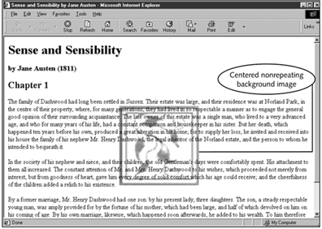

12. When using the background shortcut property, you must NOT separate each individual property with a ;, , or :.

13. The CSS color property replaces the obsolete <font> element in HTML and gives you much more precise control over element color on your Web pages.
14. There are 16 basic color names that are easy to use and recognized by most browsers.
15. The rule P {color: rgb(100%,10%,50%} sets the red value to 100%, the blue value to 50%, and the green value to 10%.
16. Hexadecimal values are always preceded by a(n) pound sign #.

17. The background-image property controls the middle layer of the Web page.
18. The following rule sets the default text color for the entire Web page to the hexadecimal value 00FF33:
body {color: #00ff33;}
19. To set the page background color, use body as the selector.
20. A(n) reverse is a common printing effect where the background color and the text color are switched.
21. To specify a page background image, use the <body> element as the selector.
22. You will always use the background-image property with the background-repeat property.
23. To put a single background image elsewhere on a page, use the background-position property.
24. The background property is a shorthand property that lets you set all of the background properties in one statement.

